Nearest pharmacy app refresh steps
GitHub repo: JinTongNHS/nearest-pharmacy-app: App to find nearest pharmacy (github.com)
- You might need to install the “PostcidesioR” package by running install.packages(“PostcidesioR”)
- Info on this really useful package can be found here: https://docs.ropensci.org/PostcodesioR/
- Download and save the latest Service registration data smoking_registrations.xlsx 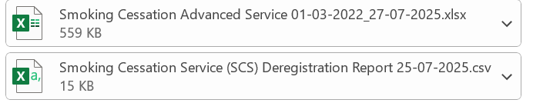to your working directory.
- When data is ready, open your nearest-pharmacy-app R project and navigate to the file “update_backing_data_for_app”
- Press source to run this file which will update all of the data needed for the app. NB: be careful about line 75 as this line will read scs registration data file from your local folder.
- Then, you can check whether this app is working by navigating to the file “nearest-pharmacy-app/all-services.R” & “nearest-pharmacy-app/SCS.R” and pressing “Run App” 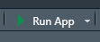
- If it works well, then you can then deploy it (i.e. make the updates available via the web link) by clicking “publish” 
  - If this is the first time you are doing it, it may prompt you to make a shiny io account. You can just select the option that does it via github
  - Make sure all files are selected (including data files – these will not be accessible to the user and only contain F codes or published data so no risk)
  - This step will take about 5-10mins depending on how fast the server is
  - Once finished, the app will pop up in a browser window
  - Copy the URL (2 links) and send to Rob Hebdon

